COMPUTER NETWORK
A computer network is a collection of interconnected devices that share resources and information. These devices can include computers, servers, printers, and other hardware. Networks allow for the efficient exchange of data, enabling various applications such as email, file sharing, and internet browsing.
How does computer network work?
Basics building blocks of a Computer network are Nodes and Links. A Network Node can be illustrated as Equipment for Data Communication like a Modem, Router, etc., or Equipment of a Data Terminal like connecting two computers or more. Link in Computer Networks can be defined as wires or cables or free space of wireless networks.
The working of Computer Networks can be simply defined as rules or protocols which help in sending and receiving data via the links which allow Computer networks to communicate. Each device has an IP Address, which helps in identifying a device.
Features of Computer Network
Some major features of Computer Network are:
- Communication speed
- File Sharing
- Back up and Roll back
- Software and hardware Sharing
- Security
- Scalability
- Reliability
Advantages and Disadvantages of Computer network
Computer Network is the base of future of evolution. So, it is important to know its advantages and disadvantages.
Pros:
- Enhancement of Communication and Information availability
- Convenient Sharing of Resources
- Easy File/Data Sharing
- Highly Flexible
- Affordable
- Enhanced Security and Data Protection
- Centralized Management and Control
- Scalability
Cons:
- Dependency on External Factors
- Security Vulnerabilities
- Lacks Robustness
- Viruses and Malware
- Bandwidth Limitations
- Privacy Concerns

Applications of Computer Network
There are variety of fields in computer networks that are used in industries. Some of them are:
- Internet and World Wide Web
- Communication
- File Sharing and Data Transfer
- Online gaming
- Remote Access and Control
- Social Media
- Cloud Computing
- Online banking and E-Commerce
- Education
- Transportation and Logistics
- Internet of Things and Smart Home
- Scientific Research
- Government and Defense
Network Protocols
In networking, a protocol is a set of rules for formatting and processing data. Network protocols are like a common language for computers. The computers within a network may use vastly different software and hardware; however, the use of protocols enables them to communicate with each other regardless.

Standardized protocols are like a common language that computers can use, similar to how two people from different parts of the world may not understand each other's native languages, but they can communicate using a shared third language. If one computer uses the Internet Protocol (IP) and a second computer does as well, they will be able to communicate.
Some common protocols are as follow:
SMTP
Simple Mail Transfer mechanism (SMTP) is a mechanism for exchanging email messages between servers. It is an essential component of the email communication process and operates at the application layer of the TCP/IP protocol stack. SMTP is a protocol for transmitting and receiving email messages.
POP and IMAP
The full form of POP is post office protocol. It is used to pull the mail from the receiver’s mail server. It works on TCP port number 110. It is a simple protocol to download the email.
IMAP stands for Internet message access protocol. It is like POP protocol. It is an advanced version of the POP protocol. It is also used to pull the mail from the receiver’s mail server. It works on the TCP port number 143.
Model of SMTP
In the SMTP model user deals with the user agent (UA), for example, Microsoft Outlook, Netscape, Mozilla, etc. To exchange the mail using TCP, MTA is used. The user sending the mail doesn’t have to deal with MTA as it is the responsibility of the system admin to set up a local MTA. The MTA maintains a small queue of mail so that it can schedule repeat delivery of mail in case the receiver is not available. The MTA delivers the mail to the mailboxes and the information can later be downloaded by the user agents.
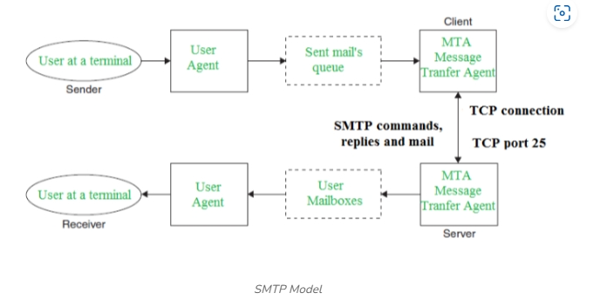

HTTP
The Hypertext Transfer Protocol (HTTP) is the foundation of the World Wide Web, the Internet that most users interact with. It is used for transferring data between devices. HTTP belongs to the application layer (layer 7), because it puts data into a format that applications (e.g. a browser) can use directly, without further interpretation. The lower layers of the OSI model are handled by a computer's operating system, not applications.
HTTPS
The problem with HTTP is that it is not encrypted — any attacker who intercepts an HTTP message can read it. HTTPS (HTTP Secure) corrects this by encrypting HTTP messages.

